Hello from Jennyruth Workshops

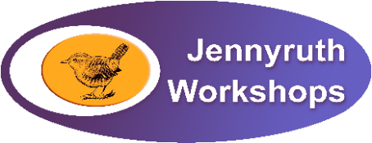

Love
Sending you love from Jennyruth and hoping you are well.
Some staff are still coming into the workshops. They are preparing packs and getting fully organised for working from home. We will keep making up the packs as long as workers are still able to come to us to pick up. If you can’t come in to collect let us know and we will see what we can do.
Keep in touch

It is massively important to us that we all stay closely connected on a regular basis.
Ways to keep in touch with us
- You can email us on: info@jennyruth.co.uk
- Phone us on 01765 606620 – leave a message if there is no-one in the office and we will ring you back
- Follow us on social media – we are on Facebook, Instagram and Twitter
- Join our private Facebook group – we are currently looking in to offering Facebook Live sessions too. Watch this space!
- Take part in our new online quizzes! – one for workers and one for staff and volunteers, to be confirmed soon
- Group chats via Zoom – watch this video clip from You Tube via the link below. This talks you through how to join a Zoom meeting for the first place.

Using Zoom
When joining your first call Zoom with us, do join about 5-10 minutes before the specified time – it always takes longer the first time.
Click on this link to find out more, and separate instructions will be emailed to you.
https://www.youtube.com/watch?v=9isp3qPeQ0E
If you are going to be joining from your phone or tablet, this is the Zoom app:
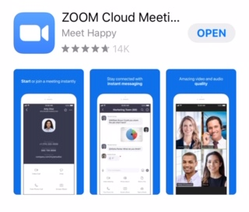

Let’s give it a try and see what happens. If nothing else, it will be entertaining!
*PLEASE NOTE THAT UNLESS WE HAVE YOUR WRITTEN CONSENT VIA EMAIL, WE CANNOT INVITE YOU TO A JENNYRUTH WORKSHOPS ZOOM CALL.
EMAIL ADDRESSES ARE SOMETIMES LISTED ON THE EMAIL INVITATION TO THE ZOOM MEETING. PLEASE DO NOT USE THIS INFO TO CONTACT ANYONE. *
Staff are having their first Zoom chat on Wednesday and we will arrange one with the workers who we already have consent from later in the week. Look out for an email from us with your joining instructions.
Until next week, take care and……..

Copyright @thehobbyroomuk
JENNYRUTH PHOTO GALLERY
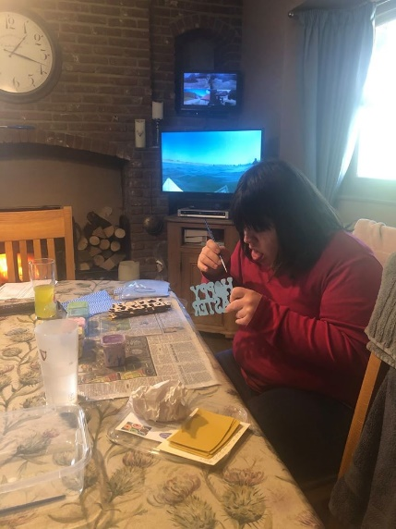
Each week we will share with you a selection of photos that have been posted on our private Facebook group page. It’s wonderful to see what the workers are doing at home. Staff and volunteers post too. If you haven’t joined us in the group yet, do join soon if you can.
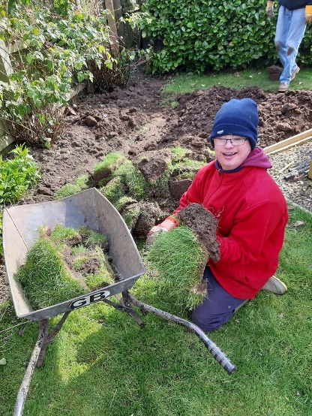
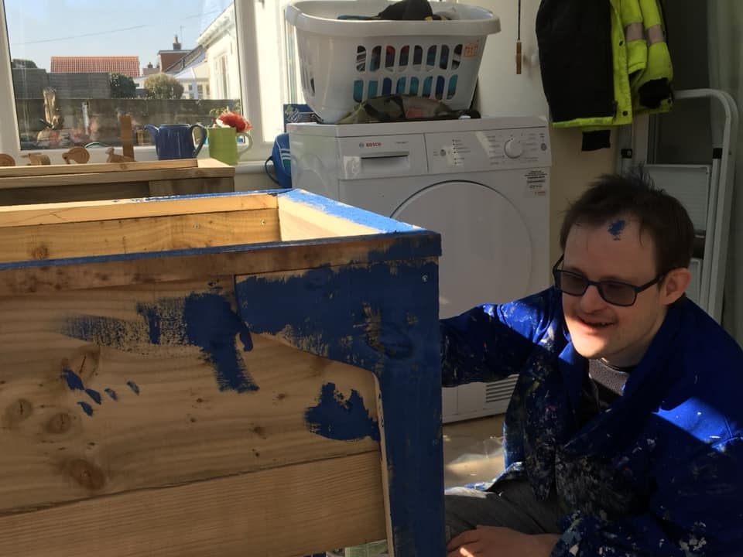

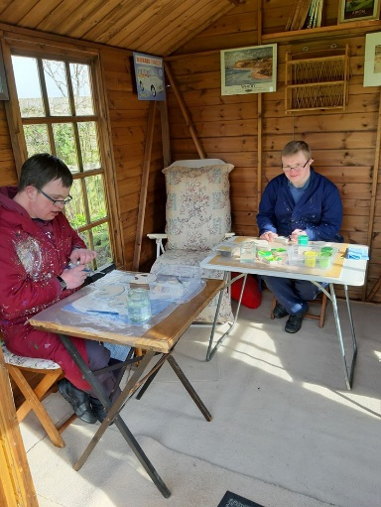

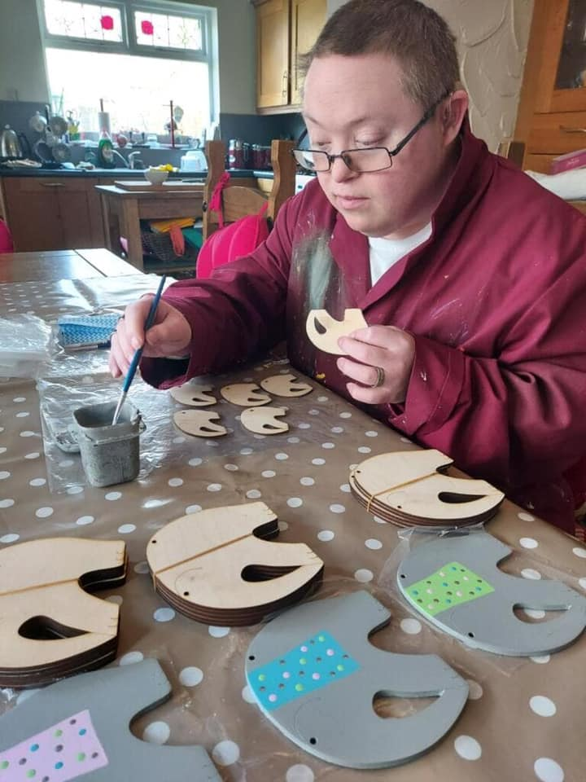

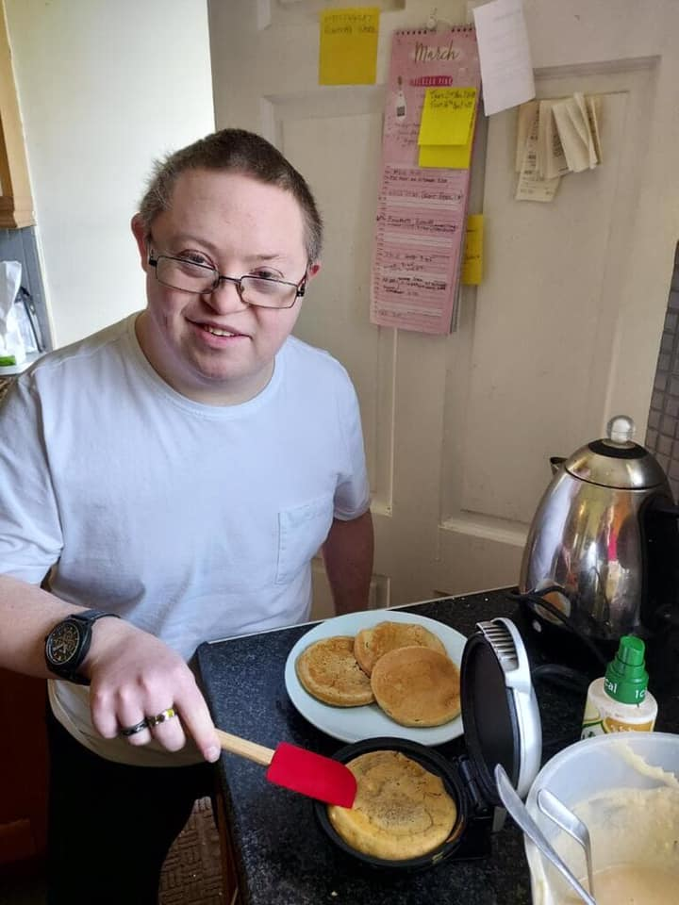
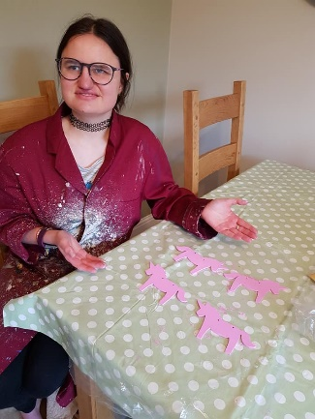
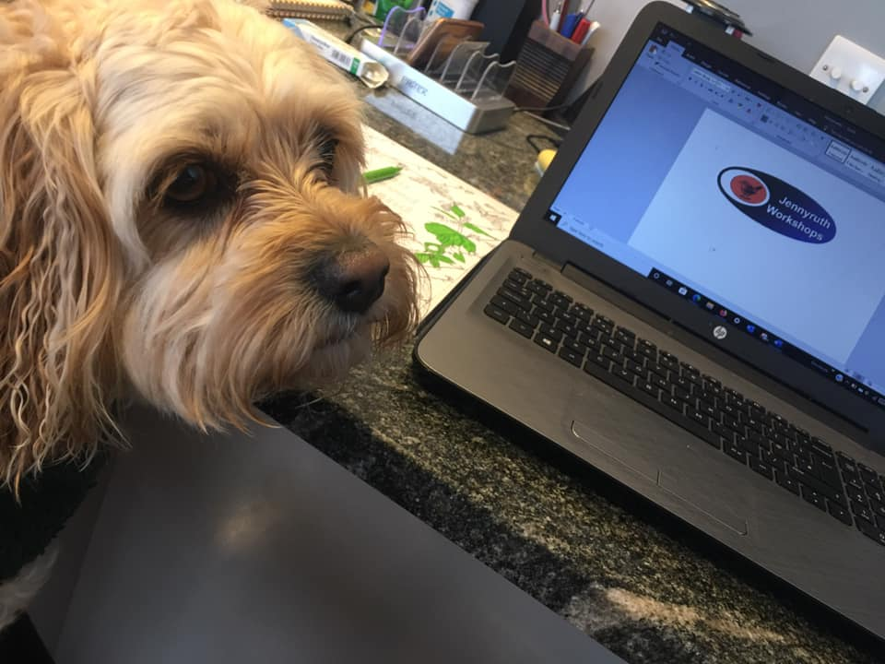

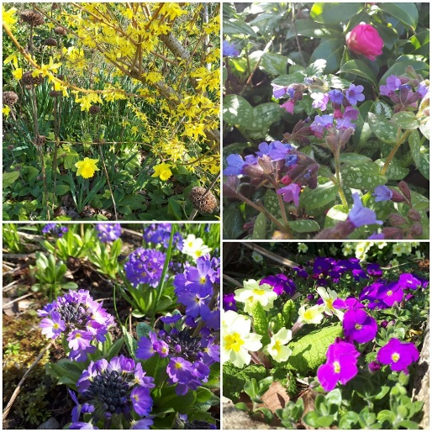
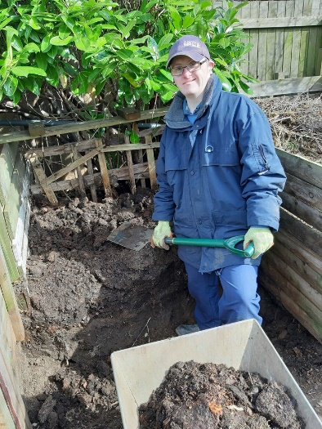
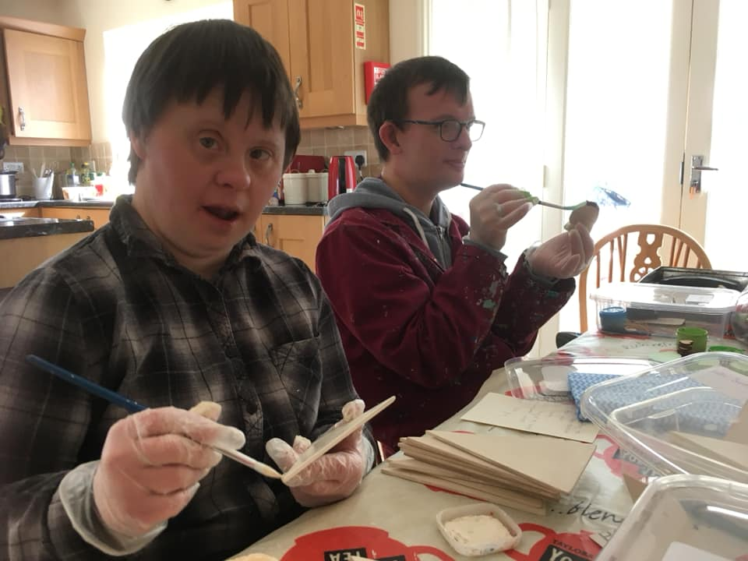

Thanks for all your amazing photos and posts. We love seeing them.

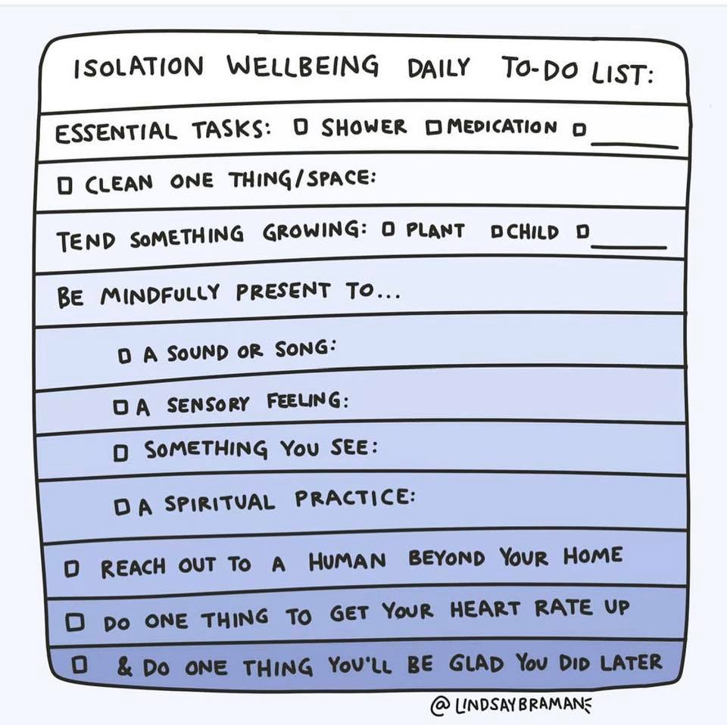

Community information:
1. Finding local support in your community during coronavirus
In a coordinated joint effort with district councils, North Yorkshire County Council is working with community organisations across the county who will work with the voluntary sector in their locality. Read more
The community support organisations will be the single point of contact for the county and district councils and working with the local voluntary sector.
People needing help can contact the County Council’s customer service centre on 01609 780780 which will direct them to the contact point in their area.
The role of the community support organisation in each locality is:
- The single point of contact for those who are alone and isolated by the pandemic
- Signposting to what local support is available in the community;
- Act as local hub for individuals and groups wishing to volunteer in the community response;
- Provide information on local shopping options and trusted suppliers who are delivering directly to those who are self-isolating.
North Yorkshire County Council has produced a flier detailing how people can find support, when they have no friends, family or trusted neighbours to help.
2. Community Support organisations in Harrogate district
HARCVS and our HELP services, is the community support organisation for Harrogate and the surrounding villages. The contact number is 01423 813096.
In other areas of our district, the Community Support Organisations (CSOs) are:
- Ripon & Villages - Ripon Community House on 01765 603631
- Knaresborough & villages - Knaresborough Connectors on 07593 882 340
- Boroughbridge & villages - Boroughbridge Community Care on 01423 324504
- Nidderdale - Nidderdale Plus on 01423 714953
- Masham & villages - Masham Community Information Office on 01765 680200
This is a limited weekday service. People with more needs and urgent need will be referred to the North Yorkshire County Council Customer Service Centre on 01609 780780.
The community support organisations would like to hear from you if you are a local community group or church organising volunteers to help people in your area during the coronavirus outbreak. Please get in touch by email:
Harrogate & Villages help@harcvs.org.uk
Ripon & Villages reception@riponcommunityhouse.co.uk
Knaresborough & Villages villagesinfo@knaresboroughconnectors.org.uk
Nidderdale admin@nidderdaleplus.org.uk
Masham & surrounding villages info@visitmasham.com
Boroughbridge & surrounding villages boroughbridgecommunitycare@gmail.com

