Hello from Jennyruth Workshops

Due to the latest advice from the Government Jennyruth Workshops will be closed for the time being. Staff are working from home, making sure we can all connect, designing new ideas for products and thinking of ideas for the workers to work on at home. Resources packs will still be put together and left in the dropbox outside JRW to be collected. These will take longer to put together now and will have to be collected. We are also looking at websites and online resources that we can recommend.
We will be setting up Zoom calls soon, but bear with us as we deal with the sudden closure of the workshops. Emails were sent out regarding getting your consent for Zoom. If we don’t get email consent we cannot include you in the Zoom chats unfortunately.
Staff are all in touch with each other and are working together to ensure that we keep the community and family feel of Jennyruth going during these uncertain times.
Our private, closed group on Facebook and at the time of writing we now have 31 members. We are sharing photos news and generally staying connected and keeping each other motivated. If you haven’t joined the group yet, there is a post on the Jennyruth Workshops Facebook page about the new group, with a join button for you to click on. If you are having any difficulties email info@jennyruth.co.uk and we will be happy to help.

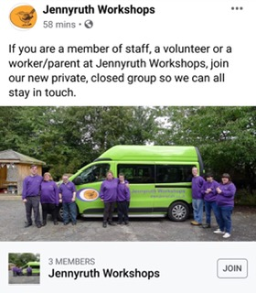

For those not on email and/or Facebook we will continue to post out this bulletin and a gallery of the photos being shared. Do let us know if you are not able to access any of the above and we will do all we can to keep you connected.

We are hoping to trial Zoom calls this week, but bear with us as we deal with the sudden closure of the workshops. Information about Zoom will also be sent out for those who haven’t had online meetings/chats in this format before. We can get through any technical difficulties together!

Staff will be taking it in turns to ring around to see how you all are. We are one big family at Jennyruth and we want to stay in touch with you.

All our best wishes and take good care.

